Before this class I knew nothing about what it was like to 3d print. In class I learned the process of printing, like how to pick a design off thingiverse, or how to create your own. I learned how to use softwear like Slicr, tinkercad, and Repitier Host. I also learned how to use the printers, like how to change the color, how to add a brim on an object, and how to heat and cool the printer I also learned how to print with more than one color. I did this on my last print, which was the snowman. When it got to the last three layers I had to change the white color to the black color, this was not hard, but required me to watch the number of layers carefully. Besides learning how to print, I also learned a lot about what printers can be used for. I never realized that with a 3d printer you can print food, wood, glass, toys, props for movies, the possibilities are endless.

The experience of printing was really new, exciting, and at times very frustrating. It was really exciting to go on thinigverse and look at all of the different possibilities of what we could print. It was even more exciting when I got to implement the ideas and then use them in my everyday life. The two prints that I use the most are a phone case and a keychain. The keychain was my first print, I put it on the keychain with my keys and SJU swipe. I used to lose my swipe all the time, but now with the bright red and kind of big key chain, it happens a lot less. I also get a lot of compliments on it. The most exciting part about printing was showing everyone what the printers could do. Most people I showed barley knew what a 3d printer was, so it was really cool to be able to explain to them how it works and what they can do.

The other print that I use everyday is my phone case, this is the print I am also most proud of. I had gotten the iphone 6 a few months ago and could not find a case anywhere. After realizing I wasn’t going to find one anytime soon, I decided to look on thingiverse and I found one. The case that I had originally wanted to use was a plain case with holes on it to expose the back. But, when I put it in Slicr the case was standing vertically, which would mean it wouldn’t print. I tried to put it in 123 Design to lay it flat, but it was taking too much time. So, I went for a simple and plain design. When I started to print it I noticed that a layer of tape was higher than the other layers. So, on my finished case there is a stripe, I think this mistake worked out in my favor because it looks intentional. Once the case was done I put it on my phone right away since the plastic still isn’t completely hardened yet, so it would mold to my phone. Whenever someone says they like my phone case, they think it is so awesome that I printed it. I am definitely most proud of this print.

While I had many successful prints, I did have a few weeks of failure trying to print a pumpkin. Right before fall break was my first attempt at printing the pumpkin, it was a jack-o-lantern where the plastic would be printed thinly on the mouth and eyes, this was so I could put light under it and it would shine through those holes. My computer was being really slow this day, a print that said it was going to take 45 min seemed like it was doubling in time. Because of this, I decided to run to my dorm and grab my bags to go home. While I was gone, my computer went to sleep, this meant that my print was canceled and all of the work I did was gone. It was very upsetting, but I learned a good lesson not to leave a print unattended for too long. The next time I tried to print a pumpkin also failed because of a time constraint. For some reason, I scaled my second pumpkin to be bigger than my first so I did not have time to finish it. Both prints started out really well, so it was upsetting to leave them unfinished. Leaving a print failed or unfinished is hard, but valuable lessons can be learned from it.

Taking a 3d printing class was an eye opening experience. Not only is it practical because we got to print practical items, it is practical since printers will become more popular in the near future. If I had to change one thing about the class it would be having some of the class set up as gathering information on what to print. A lot of weeks I had a hard time figuring out what to print, so I would just print a decoration like my bat one. But, then I would get to class and see that someone was printing an earring holder and wish I had thought of that sooner. Taking this class taught me a lot about 3d printing and what is to come, while also having the opportunity to print some cool objects.

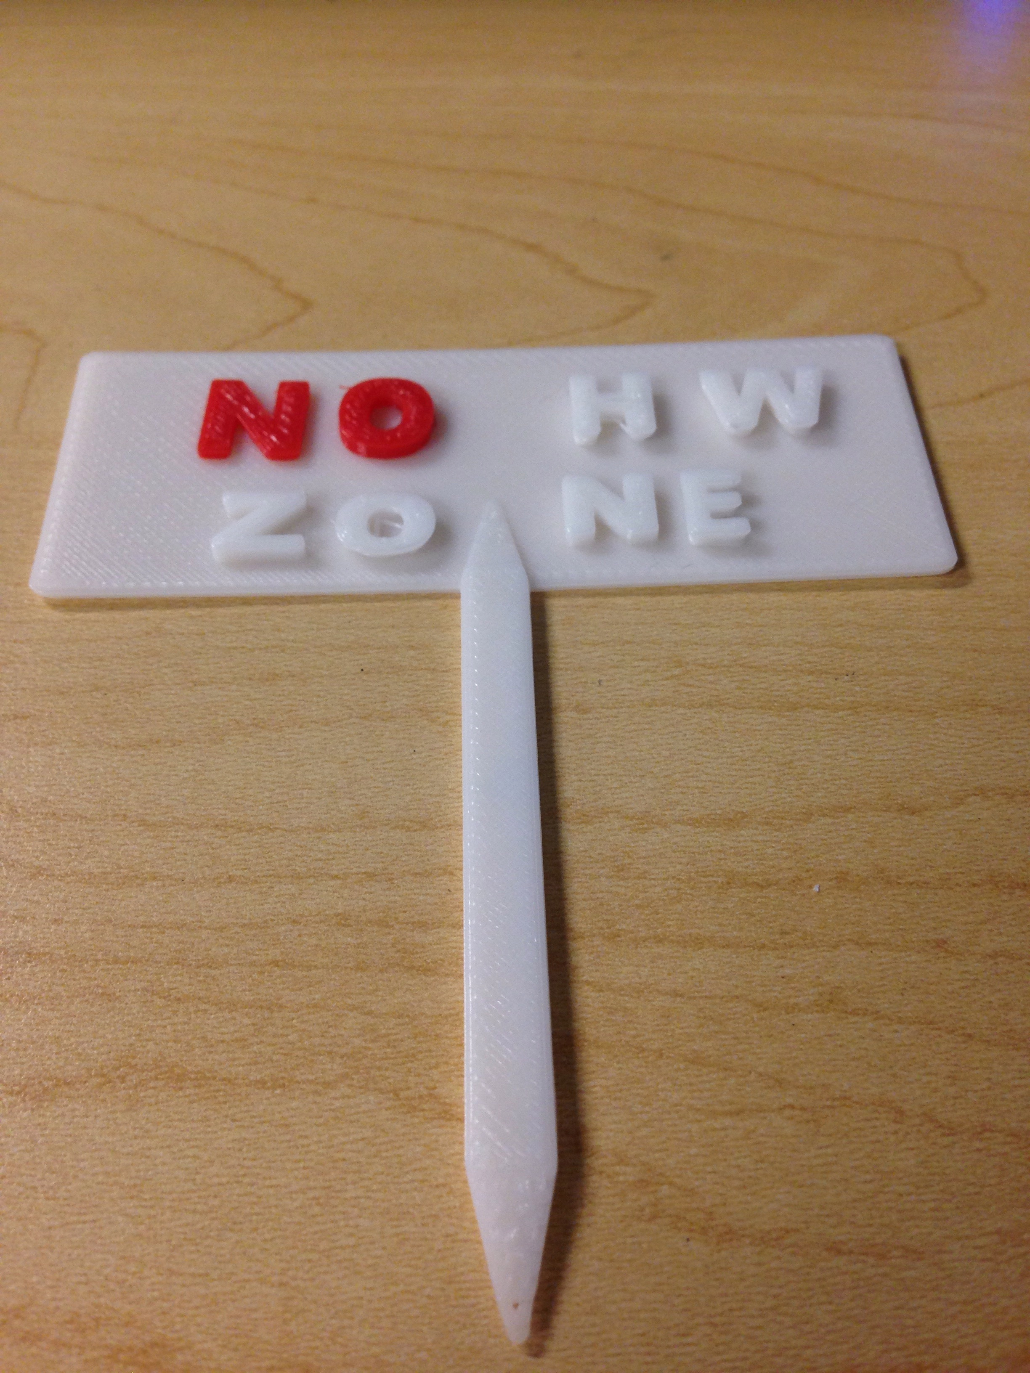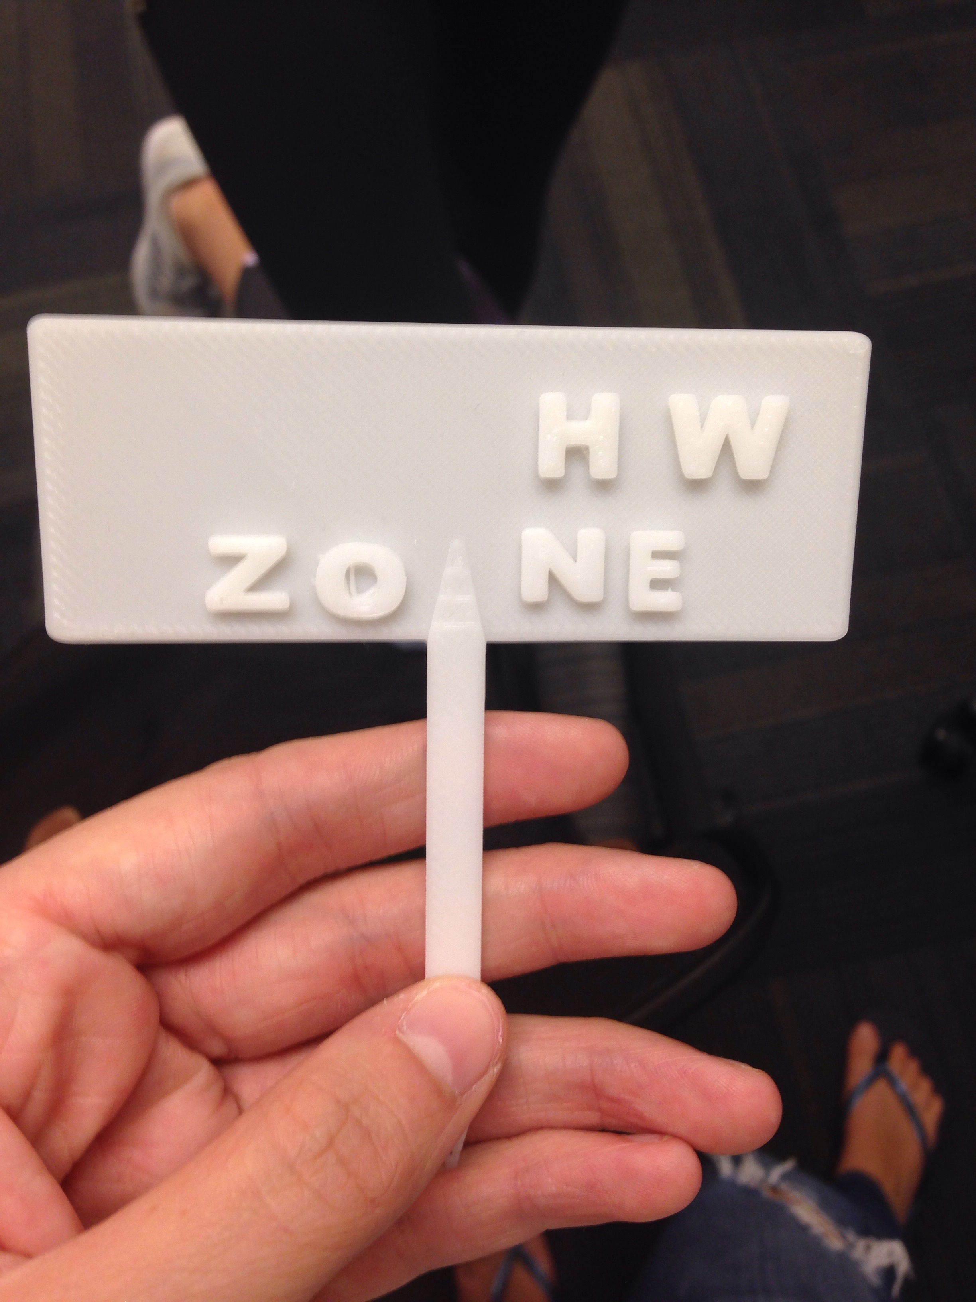

To fix my mistake I reprinted the “no” out separate. I printed it in red to stand out, and it also makes it look intentional. I used a hot glue gun to glue it on

I meant to print a “no hw zone” but the first time I tried to print the “no” printed in the air because on tinkercad I did not have the no flat on the white base.

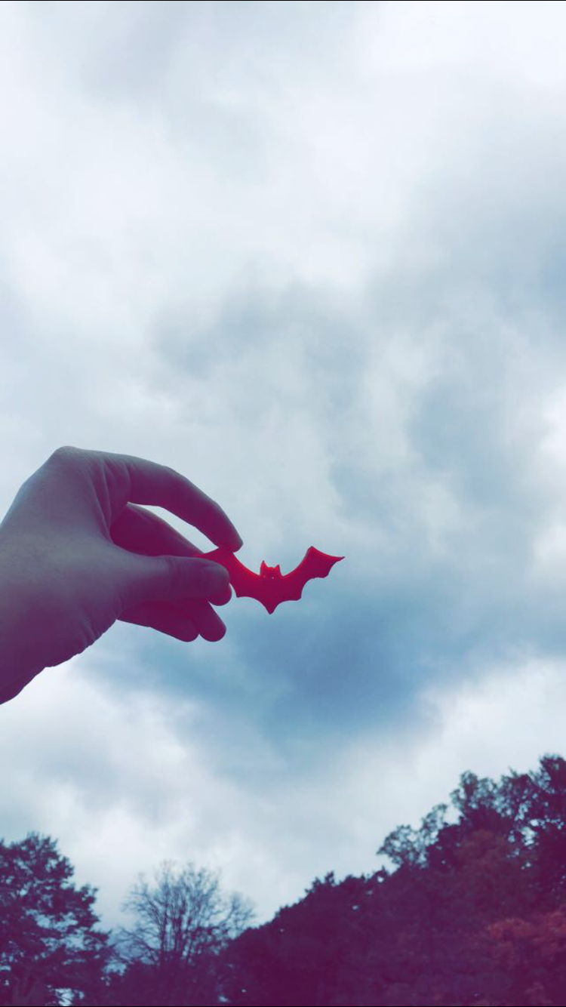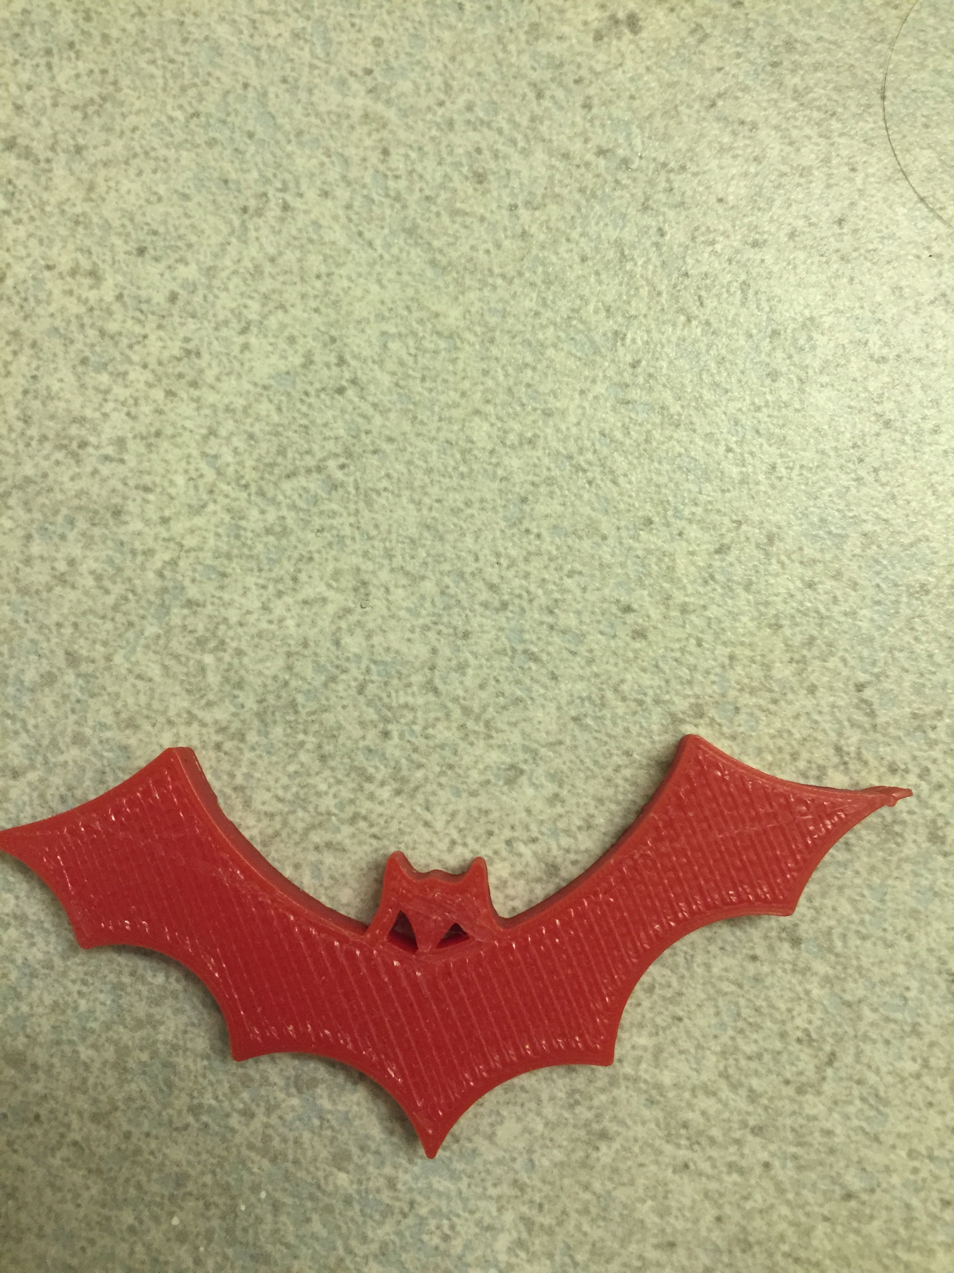

Close up of bat decoration

Halloween bat decoration flying in the sky

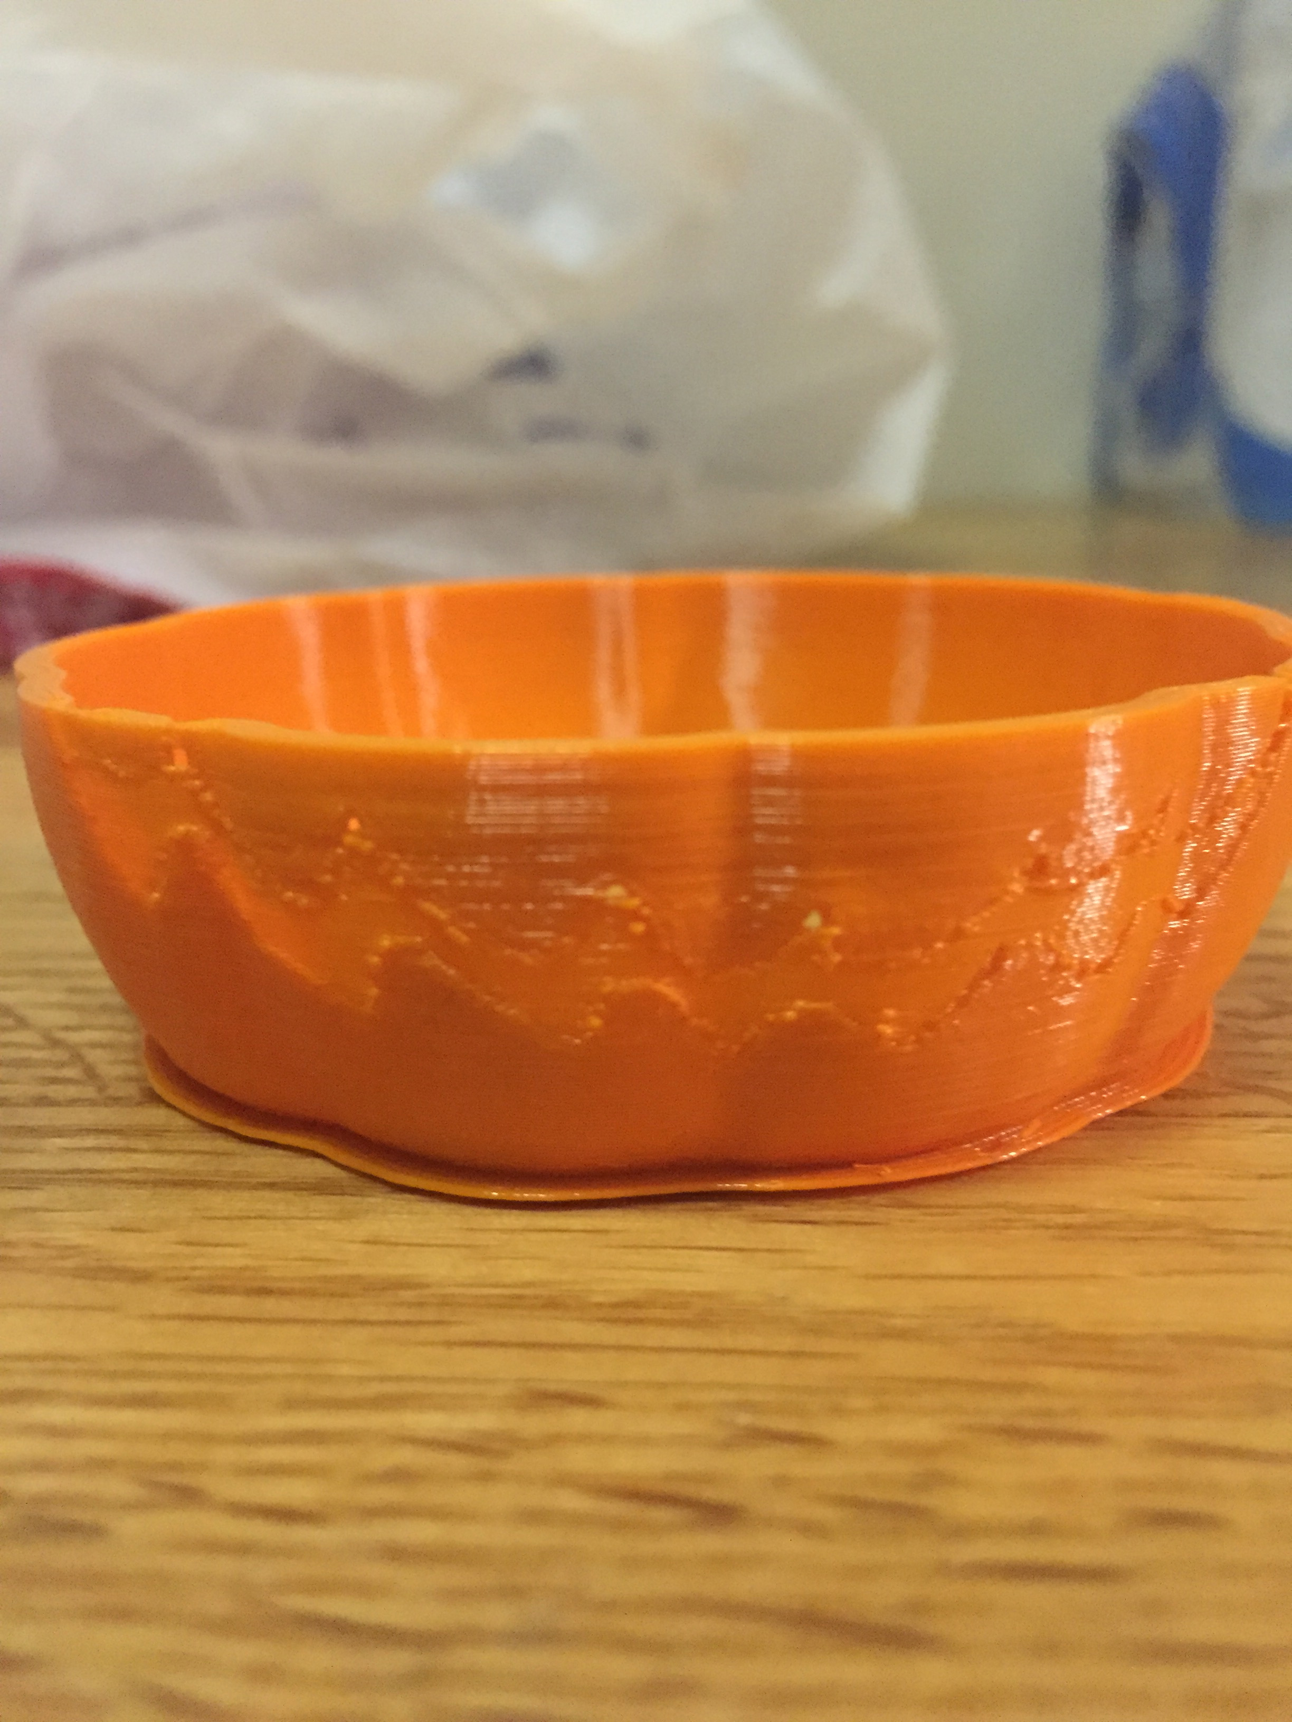

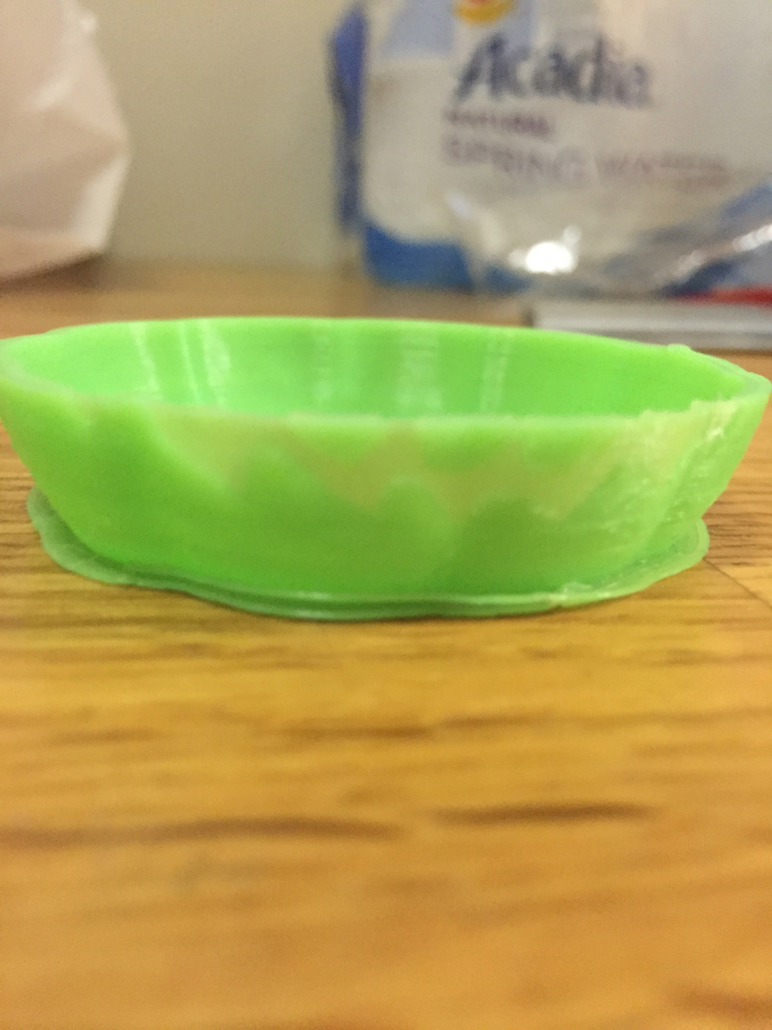

Second attempt at pumpkin, scaled it too big and ran out of time. There is also a brim on this one.

First attempt at pumpkin, print was canceled because my computer went to sleep. There is a brim on the bottom

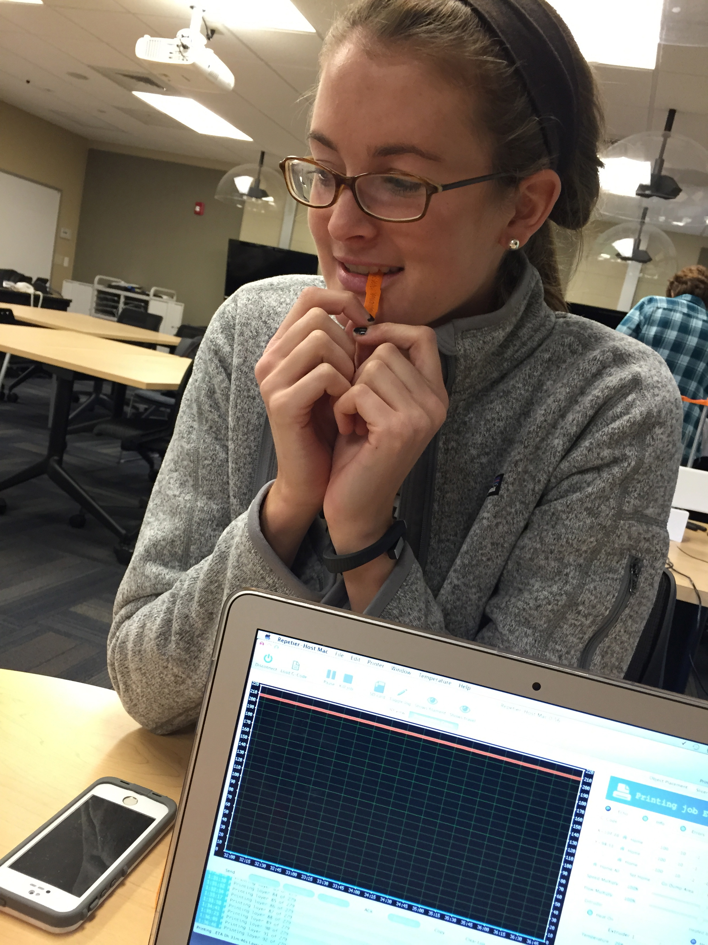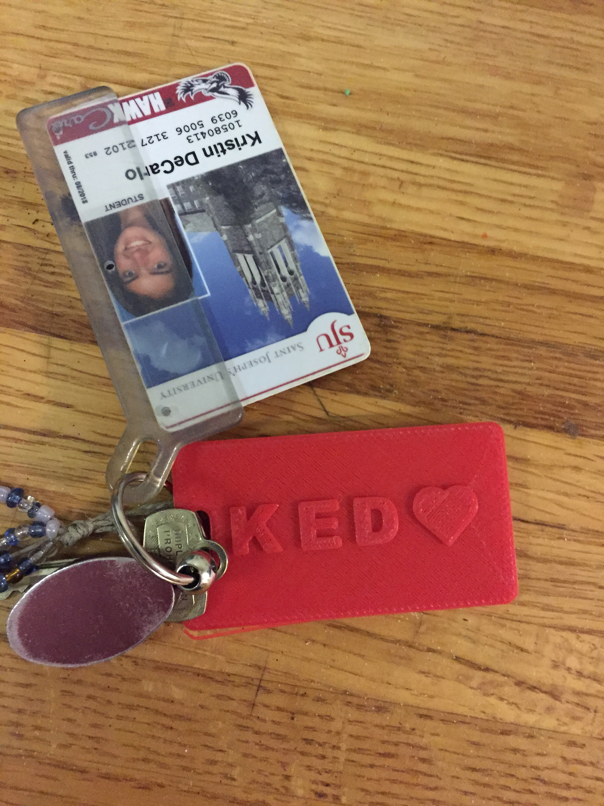

Lauren eating the plastic since we found out it was plant based and edible

Key chain

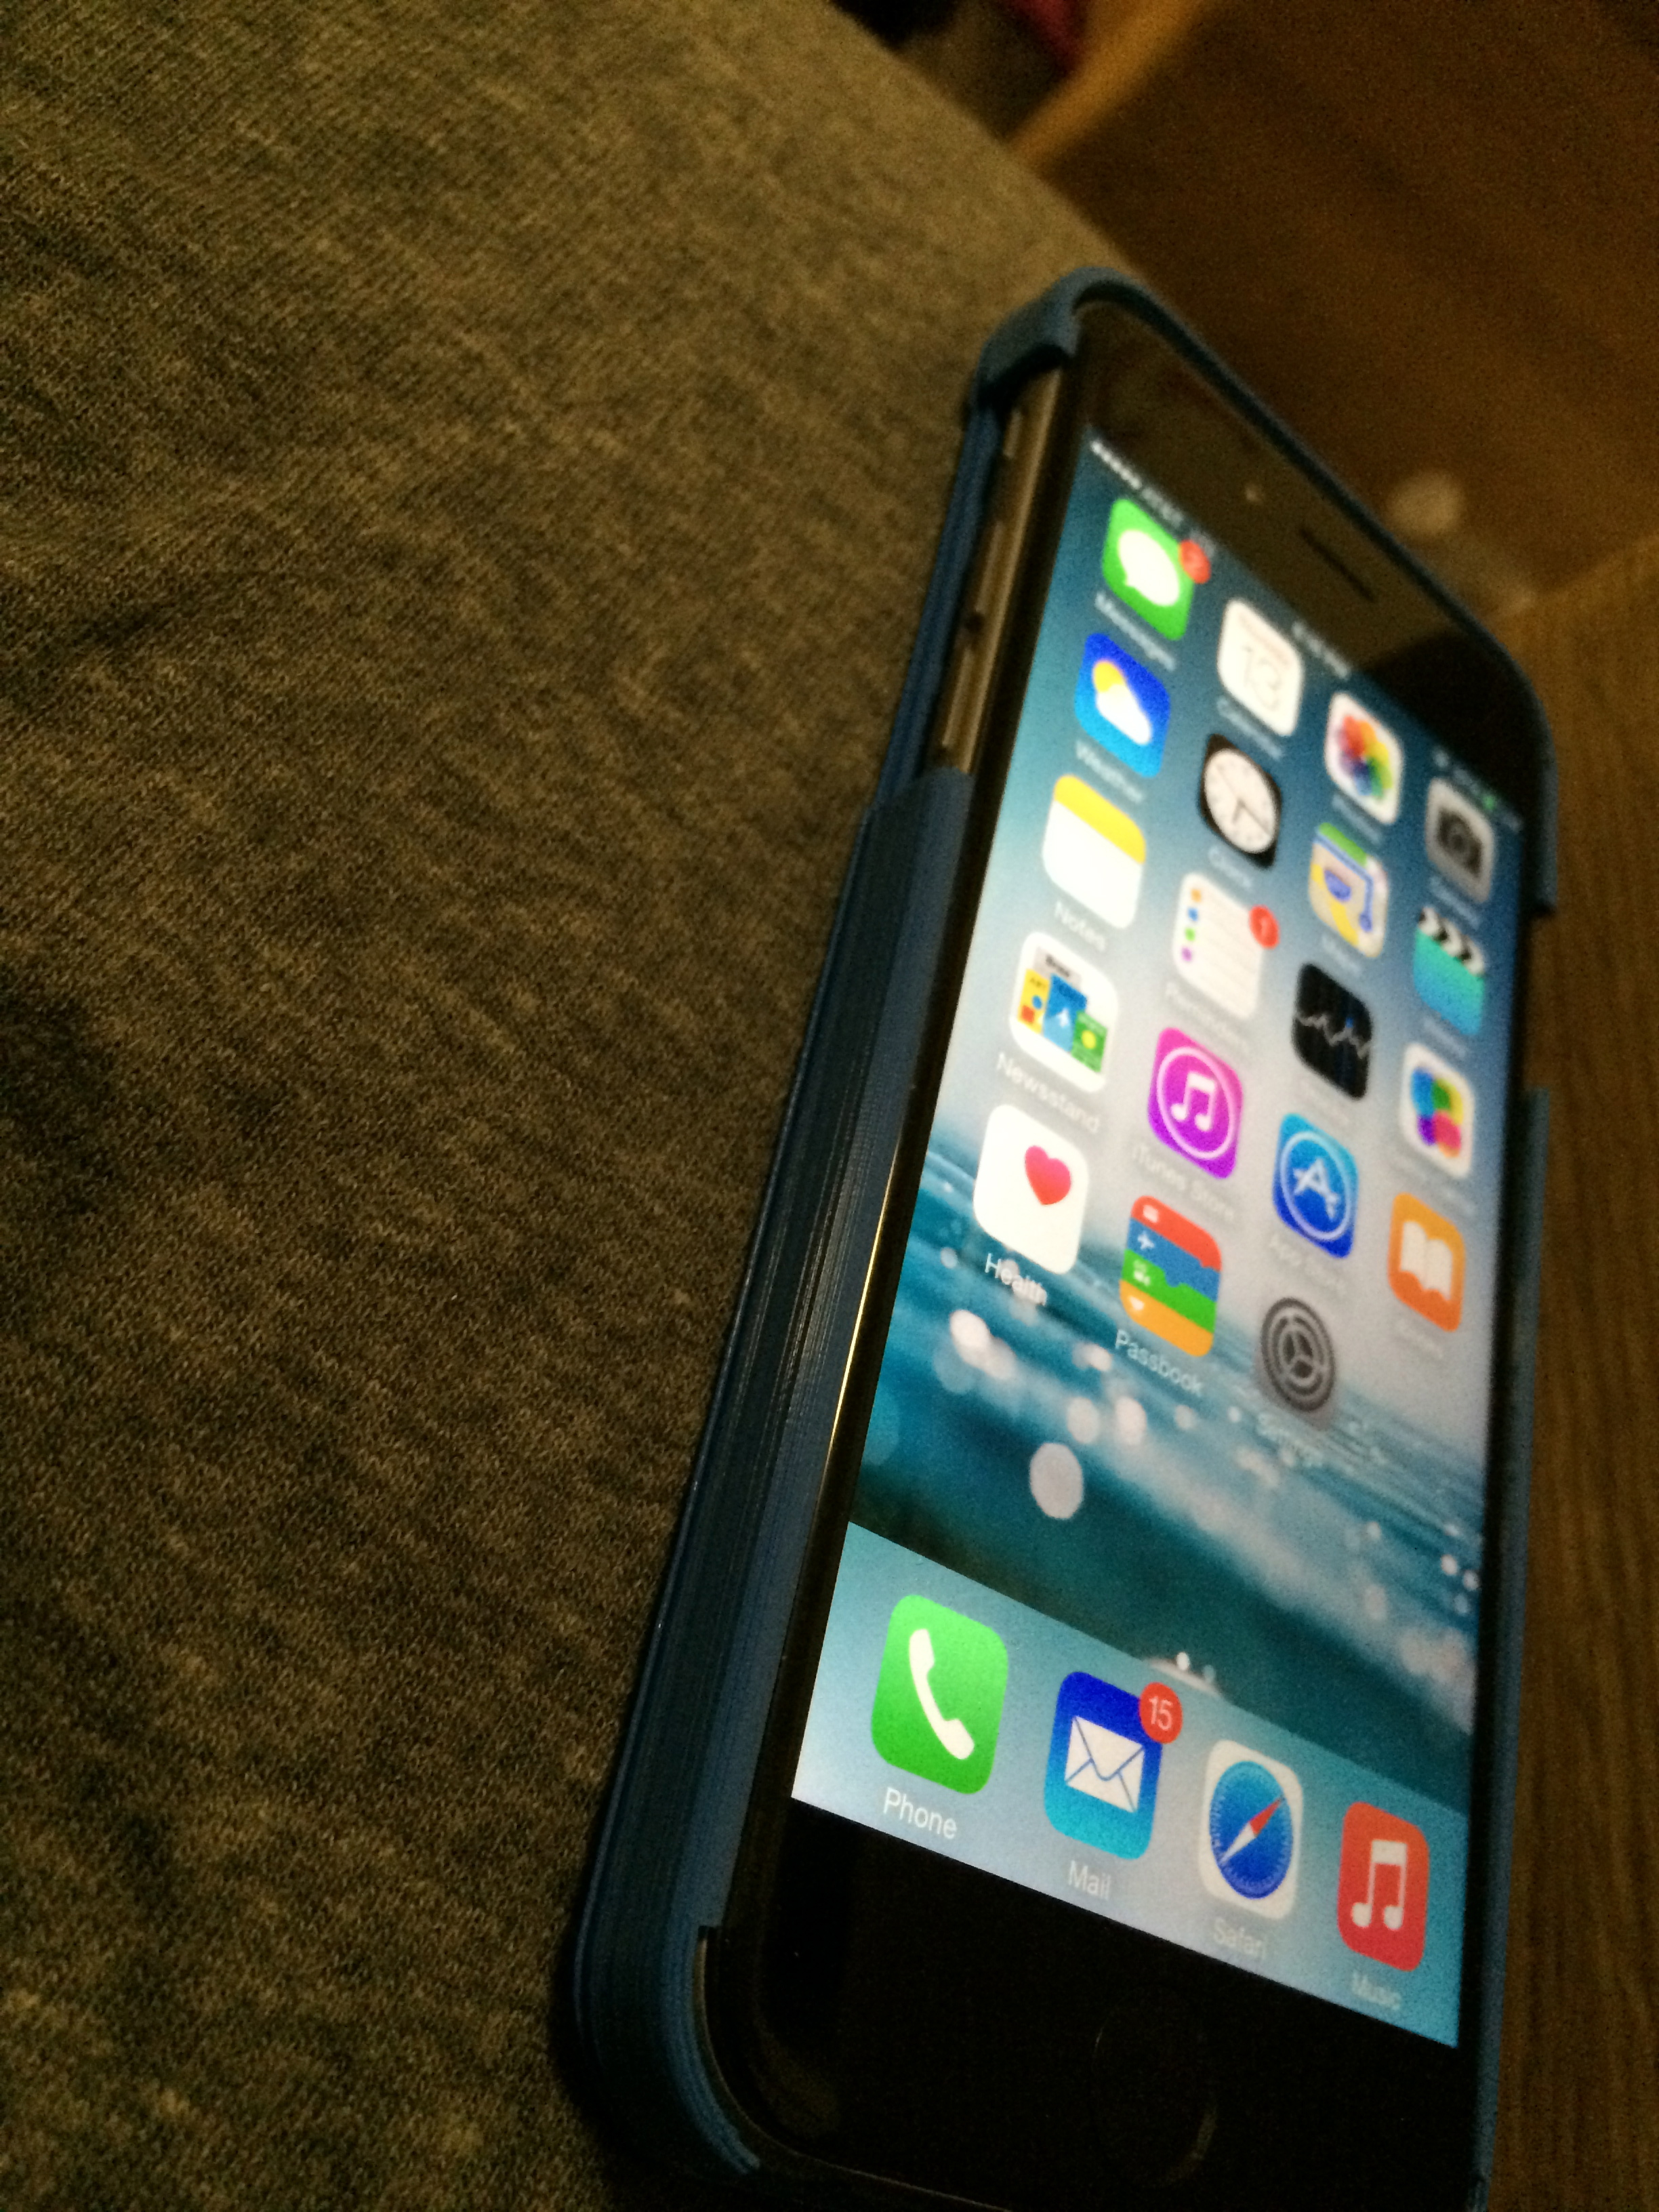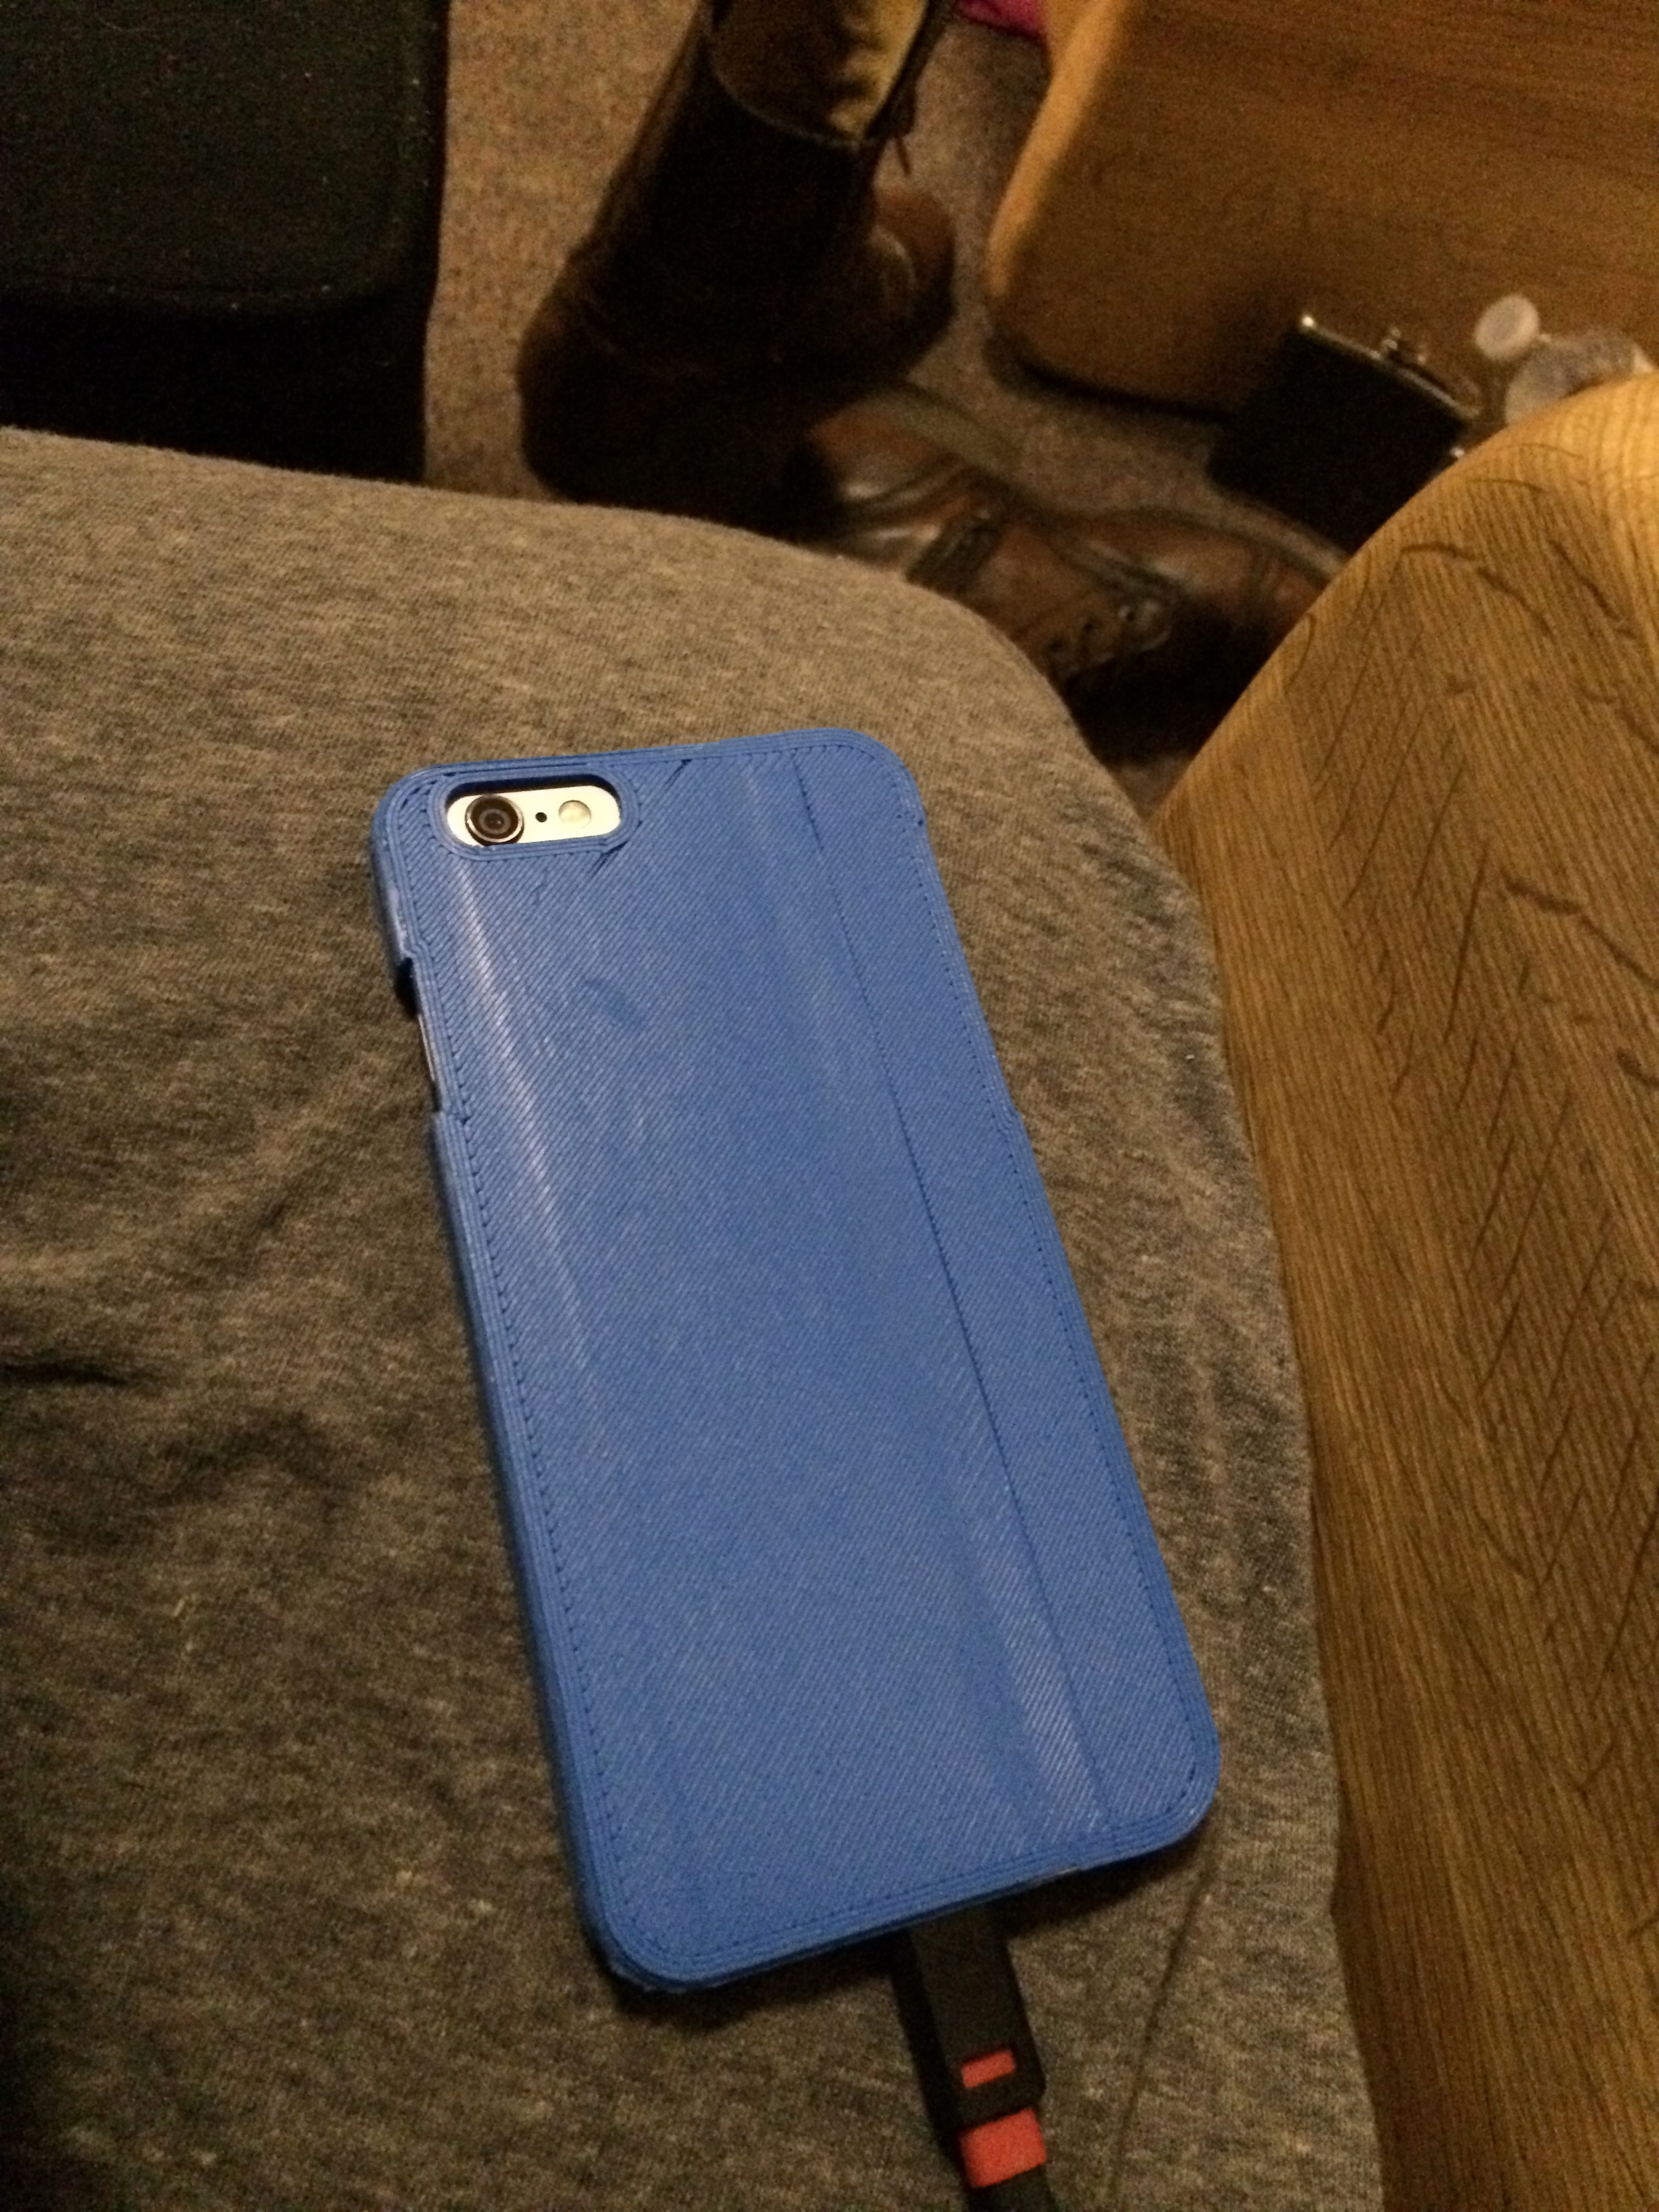

Front view of phone case

Phone case from the back. You can see the stripe that was made from the tape on the left side

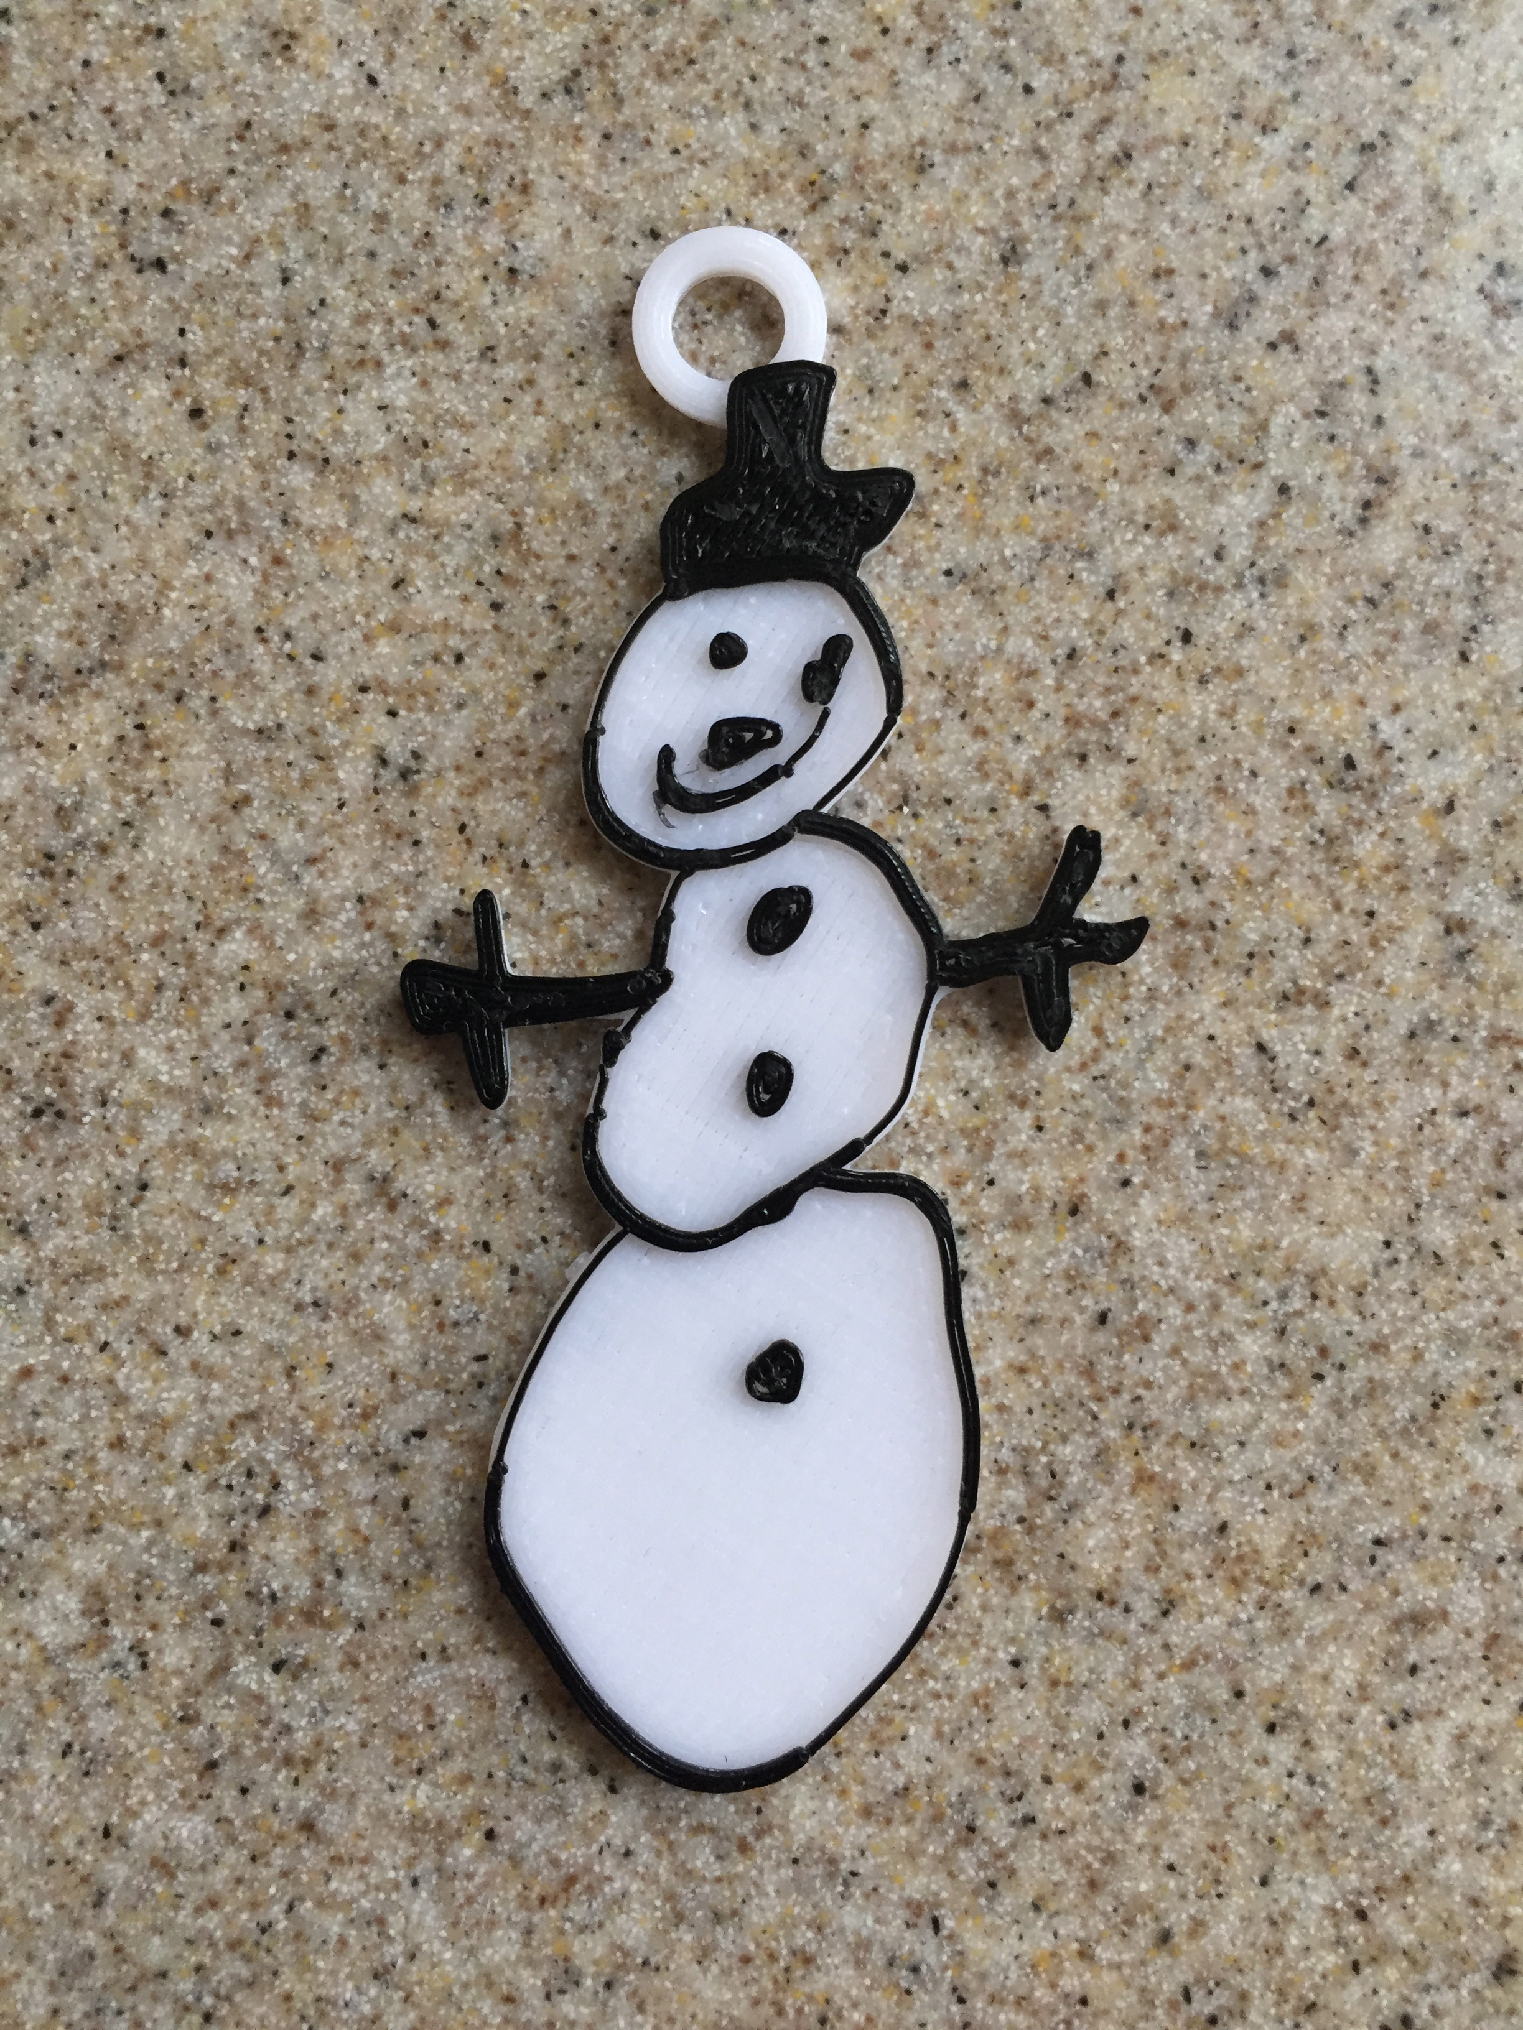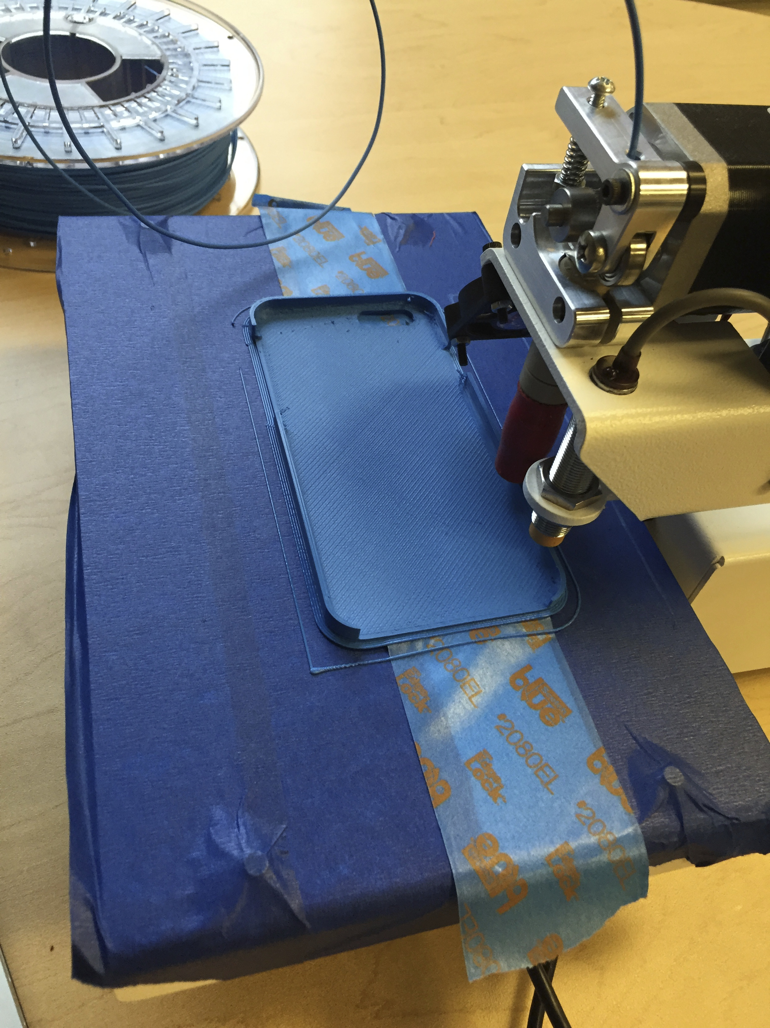

Snowman ornament with two colors

Phone case printing, the light blue colored tape with the words is what caused the stripe